Education Analytics

Summary

Published: November, 2020

Introduction 1

1) School Data Sync 1

2) Education Analytics 3

3) Open Edu Analytics 5

# Introduction

This document provides a summary of School Data Sync, Education Analytics features within M365, and the Open Edu Analytics solution. When combined, these three offerings deliver a tremendous amount of value by providing for education data collection combined with a modern data warehouse architecture that is owned and managed by you, the education customer.

# 1) School Data Sync

[Microsoft School Data Sync](https://sds.microsoft.com/) (SDS) is a free service in Office 365 for Education that reads the school and roster data from a school's Student Information System (SIS). It creates Office 365 Groups for Exchange Online and SharePoint Online, class teams for Microsoft Teams and OneNote Class notebooks, school groups for Intune for Education, and rostering and SSO integration for many other third-party applications.

SDS helps to automate the process of importing and synchronizing Student Information System (SIS) data with Office 365.

In order to configure SDS, a school administrator utilizes the [SDS admin UI](https://sds.microsoft.com/) within Office 365:

More information regarding standard integration options can be found here: [Deploying School Data Sync](https://docs.microsoft.com/en-us/schooldatasync/deploying-school-data-sync).

Another set of integration options leverages Azure Data Factory (ADF) to provide an automated, highly flexible, highly scalable, cost-effective, and secure approach that also addresses complex and high-volume scenarios. An example ADF integration solution can be found here: [openedtech/Integration_Solutions/Validate_and_upload_to_SDS](https://github.com/microsoft/openedtech/tree/main/Integration_Solutions/Validate_and_upload_to_SDS) (with accompanying documentation here: [Solution Guide: Validate and Upload to SDS](https://github.com/microsoft/openedtech/blob/main/Integration_Solutions/Validate_and_upload_to_SDS/Validate_and_upload_to_SDS.pdf)).

Once integration with SDS has been completed, customers can then enable the Education Analytics functionality through the settings page in the SDS administration page (info on [managing Education Analytics](https://docs.microsoft.com/en-us/schooldatasync/manage-education-analytics#:~:text=Education%20Analytics%20collects%20data%20from%20Education%20apps%20in,about%20the%20data%20being%20collected%20be%20found%20here.)).

# 2) Education Insights

Education Insights is a set of reports (currently in preview) enabled through SDS which collects usage data from M365 applications, including Teams, and provides school administrators and teachers with usage dashboards via the [Insights](https://support.microsoft.com/en-us/office/educator-s-guide-to-insights-in-microsoft-teams-27b56255-90c0-47aa-bac3-1c9f50157181) application.

Through the Insights application within Teams, at the individual team level, teachers are able to quickly see the level of engagement of their students within each of their classes.

Through the Insights application within Teams at the application level, school and system leaders are able to see higher level metrics across all schools, students and teachers in a single O365 subscription.

Another feature of Education Insights is the option for the customer to receive automated daily exports of the usage and roster data gathered within M365. The data exports are executed securely through the use of the [Azure Data Share](https://azure.microsoft.com/en-us/services/data-share) service, which delivers the data directly into the customer’s storage account in their Azure subscription.

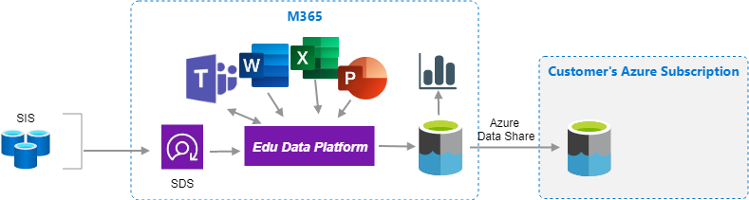

To set up an Azure subscription, customers open an Azure account and can add services at the [Azure Portal](https://azure.microsoft.com/en-us/features/azure-portal/).

By leveraging the [Azure Data Share](https://azure.microsoft.com/en-us/services/data-share) service, customers are then able to login to [Azure Portal](https://azure.microsoft.com/en-us/features/azure-portal/) and perform additional analysis on the usage data which is now in their own data lake.

# 3) Open Edu Analytics

The [Open Edu Analytics](https://github.com/microsoft/OpenEduAnalytics) solution provides a modern analytics platform utilizing [Synapse](https://azure.microsoft.com/en-us/services/synapse-analytics/) Analytics to deliver the core analytics architecture and functionality for customers to then extend as needed. The solution is comprised of Azure resources that the customer deploys within their own Azure subscription, and resulting in a solution that addresses the 3 main areas of: data collection, data enrichment and analysis, and reporting/communication.

**Security and Privacy**

Ensuring an education system’s data is secure and private is extremely important, and there are two primary ways the Open Edu Analytics solution addresses this. The first method of ensuring security and privacy is through managing access and permissions through Azure Active Directory (“Authenticate and Authorize” layer in chart below). The second method for ensuring security and privacy is through anonymizing data over which certain analytics are performed, represented below in the stage 3 data lake (step 8). These methods will be described in more detail in the **Open Edu Analytics Implementation Guide**.

**Overview of Education Insights and Open Edu Analytics**

1. A scheduled [Azure Data Factory](https://azure.microsoft.com/en-us/services/data-factory/) (ADF) pipeline extracts data from one or more Student Information Systems, converts the data into the SDS csv file format, and invokes the SDS management API to deliver the data.
2. SDS receives the inbound data and performs a match with users in Azure Active Directory (AAD), and stores the data in the Edu Data Platform, as well as creating teams or groups (if configured).
3. The Edu Data Platform captures application usage data and stores it together with roster data in the internal data lake.
4. The application usage and roster data is exported on a daily basis through the secure Azure Data Share service.
5. Additional data pipelines extract data from additional school systems.
6. The additional data is added to the stage 1 data lake.
7. The data in stage 1 is cleansed and optimized and brought into the stage 2 data lake.
8. The data in stage 2 is anonymized and brought into the stage 3 data lake.
9. Analysis is performed on anonymized data, including the training of ML models.
10. Analysis is performed on data in the stage 2 data lake, including the training of ML models.
11. Power BI dashboards and reports provide clear communication and navigation of results.
12. Outbound data pipelines allow for integration with other applications, systems or delivery of reports to parent organizations.

Through the use of the Synapse Analytics workspace, managing and working with the various analytics services is greatly simplified, resulting in a powerful solution that effectively abstracts away a fair amount of the complexity.

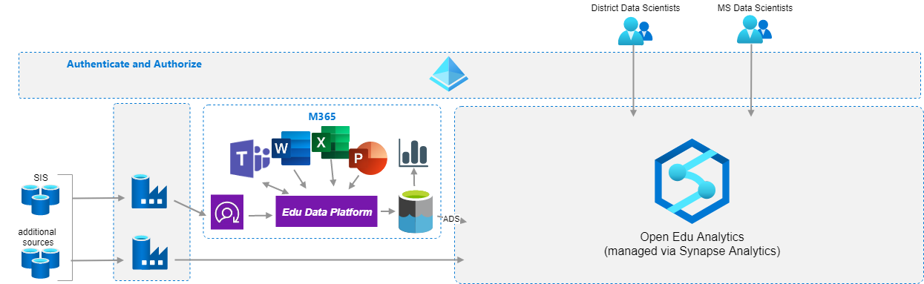

This allows Data Scientists, Data Engineers, and Analysts to all operate from within the same central workspace.

*This is a preliminary document and may be changed substantially prior to final commercial release of the software described herein.*

*The information contained in this document represents the current view of Microsoft Corporation on the issues discussed as of the date of publication. Because Microsoft must respond to changing market conditions, it should not be interpreted to be a commitment on the part of Microsoft, and Microsoft cannot guarantee the accuracy of any information presented after the date of publication.*

*This white paper is for informational purposes only. Microsoft makes no warranties, express or implied, in this document.*

*Complying with all applicable copyright laws is the responsibility of the user. Without limiting the rights under copyright, no part of this document may be reproduced, stored in, or introduced into a retrieval system, or transmitted in any form or by any means (electronic, mechanical, photocopying, recording, or otherwise), or for any purpose, without the express written permission of Microsoft Corporation.*

*Microsoft may have patents, patent applications, trademarks, copyrights, or other intellectual property rights covering subject matter in this document. Except as expressly provided in any written license agreement from Microsoft, the furnishing of this document does not give you any license to these patents, trademarks, copyrights, or other intellectual property.*

*© 2020 Microsoft Corporation. All rights reserved.*